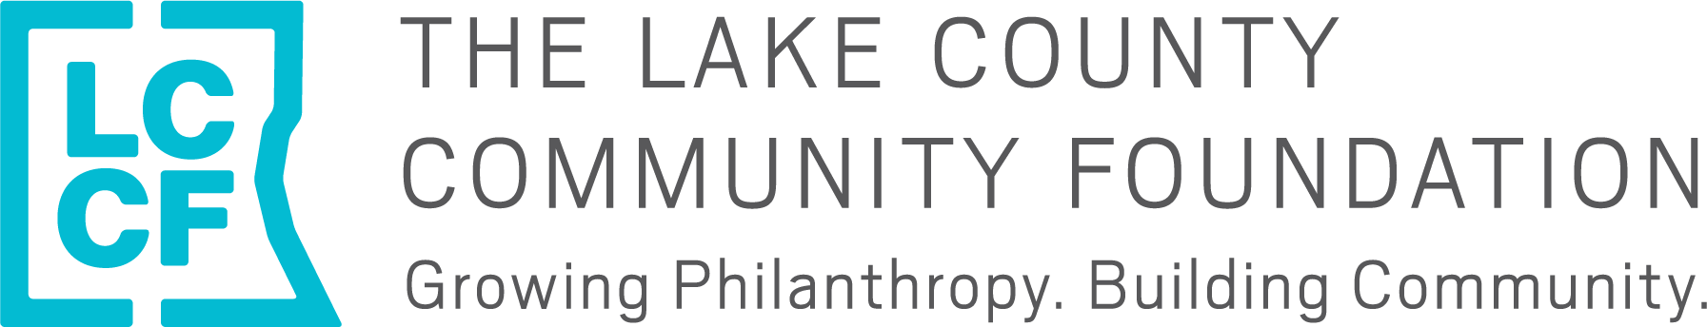

The Lake County Community Foundation
2022 Basic Human Needs Grant Cycle Letter of Inquiry

This letter of inquiry (LOI) is for LCCF’s 2022 Basic Human Needs Grant Cycle. Before completing this form, please read our 2022 Grant Making Guidelines HERE. The Foundation’s Fall Grant Cycle which includes our Early Childhood Education, Leadership Development, Animal Welfare and (new!) Capacity Building priority areas will open on August 1, 2022 and will not require an LOI.
Please Note
- Both general operating and program/project support requests will be accepted
- The maximum grant request has been increased to $50,000
- LCCF has slightly changed its grant evaluation criteria (see information on p. 5 of 2022 Grant Making Guidelines)
- Organizations are now eligible for five consecutive years of funding (as opposed to three) followed by one required rest year
- This LOI is due by 5 p.m. on Friday, Jan. 28.
- Organizations invited to submit a full application will be notified by Feb. 11.
- Full proposals will be due by 5 p.m. on March 4.

Eligibility
The Foundation considers applications from organizations that demonstrate success and sustainability with program goals and outcomes. Eligible organizations are:
- Nonprofit agencies with evidence of tax-exempt status under Section 501 (c)(3) of the Internal Revenue Code or those using a 501 (c)(3) fiscal agent
- Eligible applicants MUST be current and in good standing with the IRS
- Located within and/or primarily serving residents of Lake County, except for regional, statewide or national projects or research that may benefit a substantial portion of Lake County residents
- Non-discriminatory in the hiring of staff or in providing services on the basis of race, religion, gender, sexual orientation, age, national origin or ability

Please complete the letter of inquiry form below in Word format and submit via email to Emily Weber at Emily@lakecountycf.org by 5 p.m. on Friday, Jan. 28, 2022.

LCCF 2022 Basic Human Needs Grant Cycle Letter of Inquiry

**Please limit your response to 2 pages**

- Organization Legal Name:
  - Organization Doing Business As (DBA) Name:
  - EIN:

- Mailing Address:

- Staff Contact Name/Title/Email:

- Is this a general operating or project-based grant request?:
Grant request amount ($5,000 -$50,000): $_________

- FY22 operating budget:

- Summary budget chart:

 | Year prior to most recently completed fiscal year  (should have audit or 990 completed) | Most recently completed fiscal year  (does not need to be audited yet) | Current fiscal year budget  (entire year, not year to date)
Year
Audited (yes or no)
Revenue
Expenses
Surplus/(Deficit)
Net Assets
What is the percentage of administration costs for your organization’s budget?

- Organization mission:

- Has your organization needed to pivot in its strategic direction, service delivery model, due to budgetary constraints, or in other ways during the COVID pandemic? If so, please briefly explain.

- List and briefly describe your organization’s key programs/services, including the population served and the needs or issues that the programs address.

- Please briefly describe how the organization’s staff and board reflect the community in which it serves.

- Complete the outcomes table below with 2-4 anticipated outcomes and associated outputs and measures that you are committed to achieving during this grant period.
- The Foundation defines outcomes as benefits or changes for individuals or populations during or after participating in program activities. Outcomes may relate to knowledge, attitudes, values, skills, behaviors, conditions or other attributes.
- Outputs are the direct products of program activities. They usually are measured in terms of the volume of work accomplished, such as the numbers of participants served and materials distributed.

Outcomes | Outputs (Activities) | Measures
EXAMPLE: Adults at risk of chronic disease will improve knowledge of healthy eating through Whole Body Approach classes | - 10 Whole Body Approach classes will be provided  - 100 people will participate in WBA classes | Pre and post surveys
Please submit this letter by 5 p.m. on Friday, Jan. 28, 2022 to Emily at Emily@lakecountycf.org. Please email Emily with questions or to set up a time to talk.

