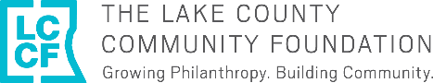
Start Something Lake County Map
Order your signed Giclée print on archival paper

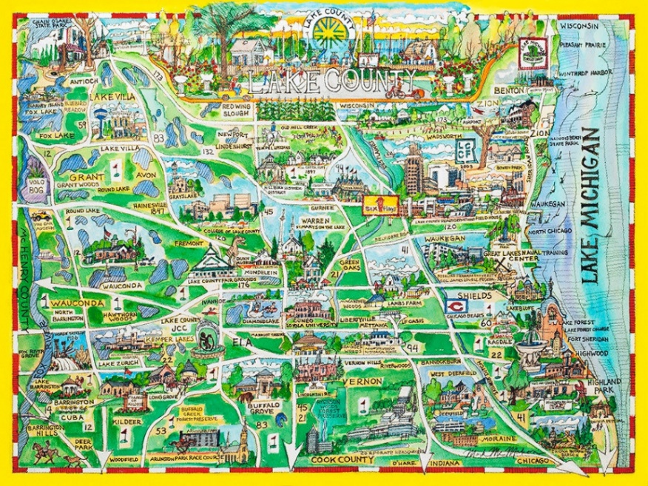

Commissioned for the
15th Anniversary of
The Lake County Community Foundation

50% of signed print sales will benefit the Robert F. Reusché Operating Endowment – Lake County’s Forever Fund

_____ 22” x 30” – original size | $400
_____ 16” x 20” | $250
_____ 10” x 12” print, matted 16”x18.5 | $175
_____ number of prints | Total = $

Order Information – all fields required

Name
Address
Email
Phone

*Framing is available at an additional charge.

