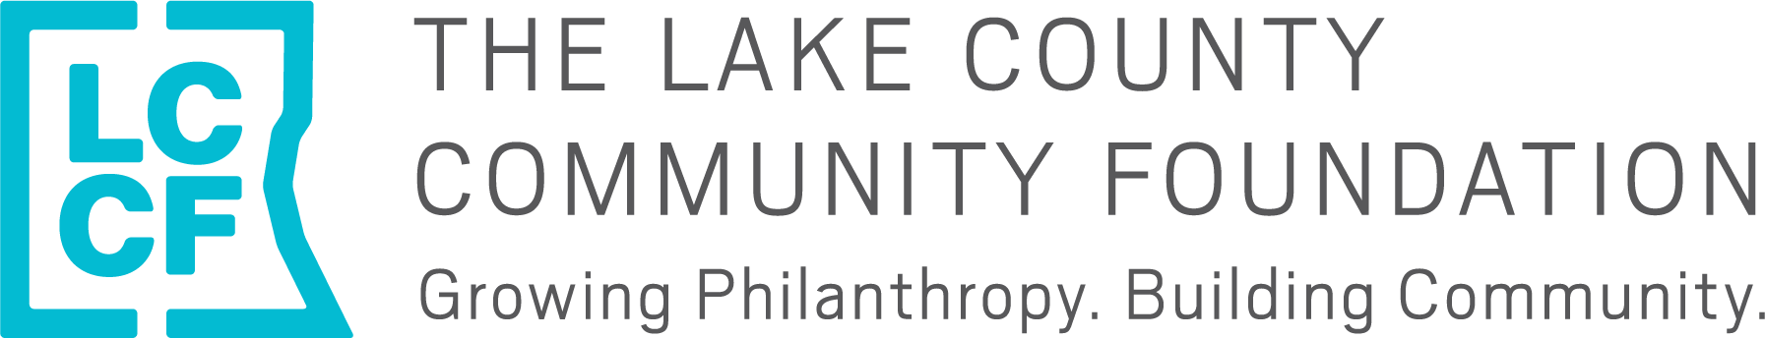

The Lake County Community Foundation
2021 Basic Human Needs Grant Cycle Letter of Inquiry

This letter of inquiry (LOI) is for LCCF’s 2021 Basic Human Needs Grant Cycle. Before completing this form, please read our 2021 Grant Making Guidelines HERE, for more information about changes to our Basic Human Needs Grant Cycle. The Foundation’s Fall Grant Cycle which includes our Early Childhood Education, Leadership Development and Animal Welfare priority areas will open on July 12, 2021 and will not require an LOI.
Please Note
- The Foundation will only accept general operating funding requests of $10,000-$20,000 for the 2021 Basic Human Needs Grant Cycle. No project-based requests will be considered this year.
- This LOI is due by 5 p.m. on Friday, Jan. 29.
- Organizations invited to submit a full application will be notified by Feb. 12.
- Full proposals will be due by 5 p.m. on March 5.

Eligibility
The Foundation considers applications from organizations that demonstrate success and sustainability with program goals and outcomes. Eligible organizations are:
- Nonprofit agencies with evidence of tax exempt status under Section 501 (c)(3) of the Internal Revenue Code or those using a 501 (c)(3) fiscal agent
- Eligible applicants MUST be current and in good standing with the IRS
- Located within and/or primarily serving residents of Lake County, except for regional, statewide or national projects or research that may benefit a substantial portion of Lake County residents
- Non-discriminatory in the hiring of staff or in providing services on the basis of race, religion, gender, sexual orientation, age, national origin or ability

Please complete the letter of inquiry form below in Word format and submit via email to Emily Weber at Emily@lakecountycf.org by 5 p.m. on Friday, Jan. 29, 2021.

LCCF 2021 Basic Human Needs Grant Cycle Letter of Inquiry

**Please limit your response to 2 pages

- Organization Legal Name:
  - Organization Doing Business As (DBA) Name:
  - EIN:

- Mailing Address:

- Staff Contact Name/Title/Email:

- General operating grant request amount ($10,000 -$20,000): $_________

- FY21 operating budget:

- Organization mission:

- Has your organization needed to pivot in its strategic direction, service delivery model, due to budgetary constraints, or in other ways during the COVID pandemic? If so, please briefly explain.

- List and briefly describe your organization’s key programs/services, including the population served and the needs or issues that the programs address. Include local data as applicable to demonstrate the need:

- Complete the outcomes table below with 2-4 anticipated outcomes and associated outputs and measures that you are committed to achieving during this grant period.
- The Foundation defines an outcome as the level of performance or achievement that occurred because of the activity you provided.
- An output tells the story of what you produced or your organization’s activities. It doesn’t address the value or impact of services for your clients.

Outcomes | Outputs (Activities) | Measures
EXAMPLE: Adults at risk of chronic disease will improve knowledge of healthy eating through Whole Body Approach classes | - 10 Whole Body Approach classes will be provided  - 100 people will participate in WBA classes | Pre and post surveys

Please submit this letter by 5 p.m. on Friday, Jan. 29, 2021 to Emily at Emily@lakecountycf.org. Please email Emily with questions or call 847-377-0520 X24.

